Policy statement on provider access

[Dixons Unity]: Provider Access Policy

Introduction

This policy statement sets out the school’s arrangements for managing the access of providers to the school for the purpose of giving them information about the provider’s education or training offer. This complies with the school’s legal obligations under Section 42B of the Education Act 1997.

Pupil entitlement

All pupils in years 8 to 13 are entitled:

- to find out about technical education qualifications and apprenticeships opportunities, as part of a careers programme which provides information on the full range of education and training options available at each transition point;

- to hear from a range of local providers about the opportunities they offer, including technical education and apprenticeships – through options events, assemblies and group discussions and taster events;

- to understand how to make applications for the full range of academic and technical courses.

For pupils of compulsory school age these encounters are mandatory and there will be a minimum of two encounters for pupils during the ‘first key phase’ (year 8 to 9) and two encounters for pupils during the ‘second key phase’ (year 10 to 11). For pupils in the ‘third key phase’ (year 12 to 13), particularly those that have not yet decided on their next steps, there are two more provider encounters available during this period, which are optional for pupils to attend.

These provider encounters will be scheduled during the main school hours and the provider will be given a reasonable amount of time to, as a minimum:

- share information about both the provider and the approved technical education qualification and apprenticeships that the provider offers
- explain what career routes those options could lead to
- provide insights into what it might be like to learn or train with that provider (including the opportunity to meet staff and pupils from the provider)
- answer questions from pupils.

Meaningful provider encounters

One encounter is defined as one meeting/session between pupils and one provider. We are committed to providing meaningful encounters to all pupils using the Making it meaningful checklist.

Meaningful online engagement is also an option, and we are open to providers that are able to provide live online engagement with our pupils.

Destinations of our pupils

Last year our year 11 pupils moved to range of providers in the local area after school:

• [Leeds City College, Notre Dame, Leeds Building College, Elliot Hudson]

Last year our year 13 pupils moved to range of providers in the local area after school:

• [N/A]

Management of provider access requests

Procedure

A provider wishing to request access should contact [Jennifer Smith], [Associate Assistant Vice Principal], [jesmith@dixonsua.com]

Opportunities for access

The school offers the six provider encounters required by law (marked in bold text) and a number of additional events, integrated into the school careers programme. We will offer providers an opportunity to come into school to speak to pupils or their parents or carers.

Apprenticeships speed networking – year 9 (28th November careers week - week 12)
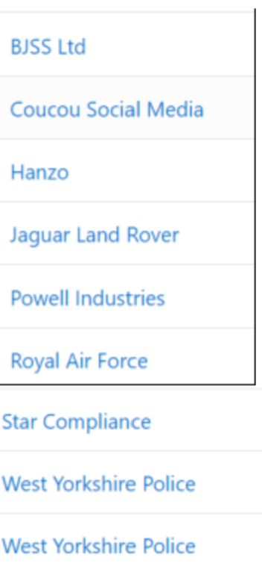
Year 8 – Northern Powergrid (30th November and 23rd March)
DWP – Civil Apprenticeships session (Monday 27th March)
Year 8 – Girltech – 17th May
Year 9 - Channel 4 – speed networking (July 8th)

Year 10 - year 11

- Year 11 - Notre Dame College - (September 29th)
- Year 11 - Elliot Hudson (November 11th)
- Year 11 - Apprenticeships.gov (September – parents evening and November – mock results evening)
- Year 11 -Leeds City College (September – parents evening and November – mock results evening)
- Year 11 -Notre Dame (September - parents evening and November – mock results evening)
- Year 10 – What is it like to be a student at Notre Dame (30th November)
- Year 11 - KPMG mock interviews (30th November)
- Year 10 and year 11 0 West Yorkshire police (1st December)
- Year 10 and year 11 Ford and Slater apprenticeships (22nd March)
- Year 10 – Notre Dame – taster of courses (26th June)

Premises and facilities

The school will make the main hall, classrooms or private meeting rooms available for discussions between the provider and pupils, as appropriate to the activity. The school will also make available AV and other specialist equipment to support provider presentations. This will all be discussed and agreed in advance of the visit with the Careers Leader or a member of their team.

Meaningful online engagement is also an option and we are open to providers that are able to provide live online engagement with our pupils.

Providers are welcome to leave a copy of their prospectus or other relevant course literature at the Careers Resource Centre, which is managed by the school librarian. The Resource Centre is available to all pupils at lunch and break times.

Complaints:

Any complaints with regards to provider access can be raised following the school complaints procedure or directly with The Careers & Enterprise Company via provideraccess@careersandenterprise.co.uk

